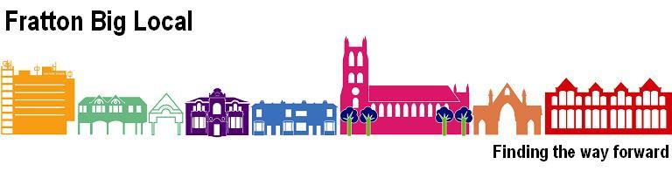

Fratton Big Local- Community Chest
Application Guidance

What is the ‘Fratton Big Local’?
Big Local is a once-in-a-lifetime opportunity for residents in Fratton to have a say on where at least £1,000,000 is spent to make a massive and lasting positive difference to the community. It’s about bringing together all the local talent, ambitions, passions, skills and energy from individuals, groups and organisations who want to make their area an even better place to live. The FBL Partnership Board has identified the following five themes on which it will base the spending of the million pounds over the next ten years:

- Making Fratton an attractive destination.

- Enhancing, and making the best use of, the green space available.

- Developing and enhancing community life.

- Working with people to help them address their aspirations, hopes & needs.

- Breaking down barriers and enhancing opportunities for inclusion.

In addition, the Partnership has the following aspirations for the community, which will:

- develop a cooperative spirit at all levels and responsive to all needs
- have increased confidence, both in itself and among individuals
- increase its capacity to engage with people’s needs and aspirations
- grow those aspirations
- increase its residents’ sense of belonging
- celebrate its achievements
- produce a coherent, vibrant, and sustainable legacy

What is the ‘Fratton Big Local Community Chest’?
As part of the first year’s grant of £100,000, the FBL Partnership will spend up to £10,000 on projects which will benefit Fratton residents, and which will fit in with one or more of the above themes and which will
help in one or more of the above aspirations. Because the funding is limited, a target of £2,500 will be allocated in each quarter of the year and a timetable for applications and decisions will be published on our website.

Who can apply?
Individuals or community groups can bid for a grant to help them run a new local project and the Partnership Board will make the final decision on which projects will be funded. Community groups must be not-for-profit and hold a bank account requiring at least two signatories.

How much can I apply for?
Applications may be made for between £100- £300, in exceptional circumstances £500 may be awarded. (Funding must be spent within 12 months of the grant being awarded)

Important points to consider when making an application
- Ensure your project benefits the residents of Fratton.
- Applications should be for new activities or projects.
- If your application involves contact with children or vulnerable adults you will need to satisfy us that all the required DBS* checks have been carried out.
- Remember, you can apply for a grant between £100- £300.
- If applying towards a larger project all other funding must be in place.
- If your application is successful you will be required to have spent the funding and complete a monitoring and evaluation form at least twelve months after the funding has been received. This form will include a spend breakdown, and we reserve the right to also ask for receipts/invoices.
- Successful applicants will also be expected to display the Fratton Big Local logo on all publicity relating to the funded project.
- All applications should include estimates of the costs involved (including VAT), evidence/receipts will be required as part of the monitoring and evaluation at the end of the project.
- Funding will not be provided on a retrospective basis and organisations should not commit themselves to the project before any final decision is made.
- If your application is successful you will receive 2 copies of an offer letter which will specify any conditions regarding your project. You will need to return a signed copy before any funds are released.
- Decisions made by the Partnership Board are final.

The Fratton Big Local Community Chest will not grant fund:
- Projects which relate solely to religious purposes,
- Projects which exclude certain members of the community,
- Projects which will only benefit one individual,
- Political activities,
- Projects that do not benefit residents living in Fratton.

You will be required to demonstrate the effectiveness of your Project.
This may take the form of a questionnaire completed by participants, a survey carried out online, a video film or other form of report. In your application tell us how you plan to demonstrate how effective your project has been.

*DBS Disclosure and Barring Service http://www.ddc.uk.net/

For further information contact:

Fratton Big Local
c/o Fratton Community Centre
Trafalgar Place
Fratton
Portsmouth PO1 5JJ
office@frattonbiglocal.org.uk

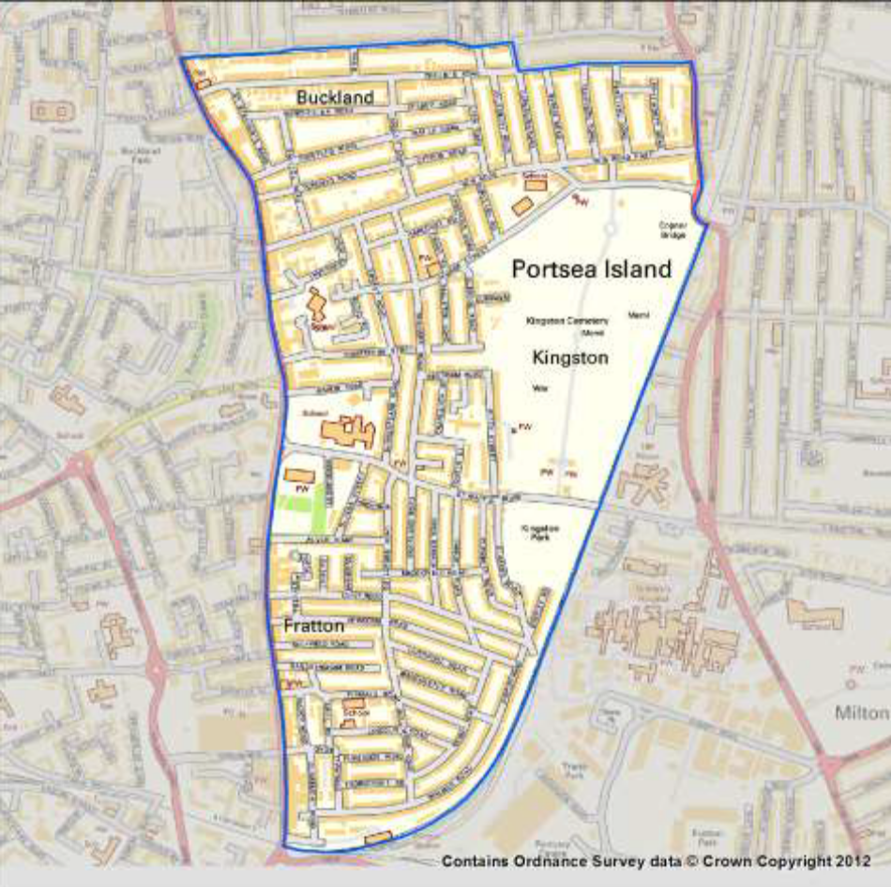
Fratton Big Local’s Area of Operation

